Pastoral Care – Mental Health

Definition and Classification
Defining mental illness is difficult but having definitions can be helpful in determining treatment and improving understanding.
No mental disorder is purely ‘mental’ because the whole person is involved: we are ‘psychosomatic wholes’ to quote Professor Alan Thomas.
- Mental health disorders tend to be grouped into:
- Anxiety Disorders
- Mood Disorders
- Stress and Adjustment Disorders
- Psychotic Disorders
- Eating Disorders
- Substance misuse and addiction Disorders
- Neurodevelopmental Disorders
- Personality Disorders
- Dementia and Neurodegenerative Disorders

The two main classification systems used in Health services throughout the world are the:
- DSM (Diagnostic and Statistical Manual), currently in version 5 and the
- ICD (International Classification of Diseases) with ICD-11 just coming into use.

The DSM is from the USA, the ICD is from the World Health Organisation and they are not totally compatible.
DSM-V has added many new diagnoses which will probably not be accepted in the NHS as it is the ICD which is mainly in use in the UK.
Many people, including some psychiatrists, argue that there has been an overmedicalization of everyday distress but there is an increasing demand for mental health services, especially among the young.

Stress-vulnerability model of mental illness
This is a way of looking at mental illness in terms of predisposing factors which increase the likelihood of becoming mentally unwell in response to physical and/or psychological stress. There is much that can increase a person’s vulnerability, but significant factors are:
- Genetics
- Childhood experiences, particularly abuse
- Physical ill-health
- Alcohol and substance use
- Relationship difficulties
- Unemployment, poor housing, poverty
- Previous episodes of mental illness
- Trauma
- Smartphone use among young people now recognized as contributing to anxiety

Many of these factors are interrelated.
Severe mental illnesses contain a large biological component, the psychosomatic ones have a smaller biological contribution. It is now generally accepted that faith can be a protective factor but having faith does not confer immunity from mental illness.
As Roger Carswell, a well-known evangelist who has experienced episodes of severe depression, says, “The fall has wrecked our beings, and we can be affected physically and mentally”.

Treatment of mental disorders
Psychological approaches are usually recommended as the first line of treatment, especially for anxiety and depression, the commonest mental health problems.
These include:
- Cognitive Behaviour Therapy (CBT diagram on page 4)
- Mindfulness
- Other short-term psychological therapies
- Psychotherapy
- Counselling - like psychotherapy but some prefer the term as it may seem less illness-related.

Medication for mental disorders falls into the following main categories:
- Anxiolytics – rapid relief of anxiety. Effective in the short-term but can be addictive and tolerance may develop. E.g. diazepam, lorazepam

- SSRIs (Selective Serotonin Reuptake Inhibitors) e.g. Fluoxetine, Citalopram, Sertraline. Used for anxiety and also as first-line antidepressants.

- Antidepressants e.g. Amitriptyline, Venlafaxine which are used as second-line drugs and are often more effective in severe depression than SSRIs. They also tend to have more side-effects.

- Antipsychotics are used in the treatment of schizophrenia but may also be used in addition to antidepressants in psychotic depression or for manic episodes. Unwanted side-effects can make people reluctant to stay on these drugs.

There are also drugs used in the treatment of bipolar disorder to prevent mood swings (Lithium and some anticonvulsants), medication used for the management of ADHD, and some more controversial drugs under investigation for treatment-resistant conditions e.g. Ketamine for severe depression.

ECT (Electroconvulsive therapy) is still used in some cases of very severe depression when it can be lifesaving.

Mental Health Legislation
The Mental health Act allows for detention and treatment against a person’s wishes. It is only meant for use when there is no other way to keep the ill person, or the public, safe. It is currently being revised.
The Care Act (2014) is concerned with the care of adults who lack capacity to make decisions about their personal and social care.

What else helps to improve mental wellbeing?
- Supportive relationships
- Purpose and Hope
- Gratitude
- Contact with the natural world
- Healthy lifestyle – exercise, sleep, diet

Some sources of further information (see digital version at ccd.church/leaders to be able to click the links)
Royal College of Psychiatrists - https://www.rcpsych.ac.uk/mental-health/mental-illnesses-and-mental-health-problems
MIND - https://www.mind.org.uk/information-support/
Mind and Soul Foundation - https://www.mindandsoulfoundation.org
Mental Health and Your Church – a book by Helen Thorne and Dr Steve Midgley from Biblical Counselling UK
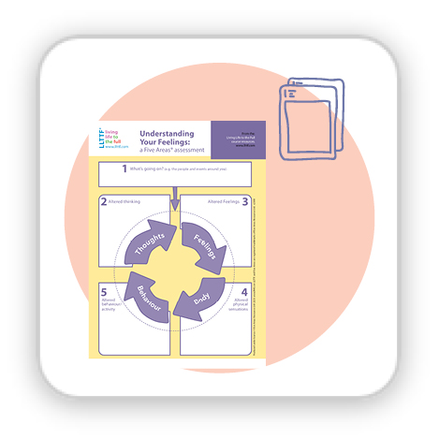
I’m not supposed to feel like this – a Christian Self-Help Approach to Anxiety and Depression. It is a workbook using a CBT approach.

Diagram of CBT from ‘Living Life to the Full’
www.llttf.com

