**PREDICTIVE TEXTS? HOW IS OLD TESTAMENT PROPHECY FULFILLED?**

© David Green (London Seminary) for Christ Church, Dunstable, 2024

A quick word on what we mean by ‘fulfilment’

**FULFILMENT IN CHRIST**

Luke 24:25-27; 44-47 – 1 Peter 1:11-12 – this tells us something important about the OT.

**PROPHECY IS MORE THAN PREDICTION**

* Prophecy includes prediction – Deut 18:14-22
* Not all prediction is prophecy
* Predictive prophecy brings about the future– Josh 6:26 (Jer 28:15; Lk 1:20)
* Some predictive prophecies are conditional (Isa 38:1-8; Jonah 3:4; Jer 18:7-10; Luke 13:3-4)

**A SIMPLISTIC MODEL OF PREDICTIVE PROPHECY**

Henry Liddon: 332 distinct prophecies literally fulfilled in Christ. Probability:

1: 840, 000, 000, 000, 000, 000, 000, 000, 000, 000, 000, 000, 000, 000, 000, 000, 000, 000, 000, 000, 000, 000, 000, 000, 000, 000, 000, 000, 000, 000, 000, 000, 000, 000.

**A RICH MODEL OF THE FULFILMENT OF SCRIPTURE: MATTHEW 1 AND 2**

Matt 1:1 = Gen 5:1 (John 1:1 = Gen 1:1)

Matt 2:6: = Mic 5:2

Matt 2:15: = Hos 11:1

Matt 2:18: = Jer 31:15

Example of how Jesus answers the OT’s unanswered questions: Exod 34:6,7 – Jn 1:17 – Rm 3:21-26

**THE OLD TESTAMENT PREDICTING THE FUTURE**

**‘Future-Time Indicators’:** ‘in/on that day’ (found over 100 times in prophetic books)

‘in days to come’ / ‘in the latter days’ / ‘in the last days’

‘the days are coming’ (Jeremiah)

‘Day of the LORD’ passages.

**Horizons of fulfilment:**

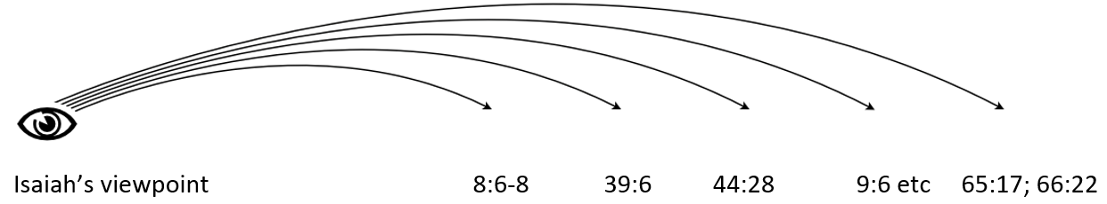

A word on Exile

**Multiple Horizons?** Isa 61:1, 2; Isaiah 7:14; the ‘Abomination of Desolation’

**LITERAL OR SYMBOLIC FULFILMENT**

Will lions eat straw, or the church’s enemies be tamed?

Isa 7:14 = Matt 1:20-23 – what is a ‘literal’ fulfilment of the Immanuel prophecy?

‘Reformed’ versus ‘Dispensational’ approach to the fulfilment of prophecy.

**METHODOLOGY FOR INTERPRETING OT ESCHATOLOGY**

1. Start with the nearest horizon – the prophet’s own day and situation.
2. Consider all possible horizons.
3. Consider how the New Testament uses the passage, if it is quoted in the NT, bearing in mind that NT writers may use the same passage differently
4. Don’t expect scientific precision in OT eschatological prediction.
5. All OT eschatology points to something about Christ, even if it is not a ‘prediction.’

**CONCLUSIONS**

* God is wonderfully unpredictable and yet has made himself predictable.
* The written word of Scripture is fulfilled in the person of the living word, Jesus Christ.
* Jesus fulfils not only predictions, but the theological themes of the Old Testament and is the answer to its unanswered questions.
* The OT points to future events which are fulfilled on several historical horizons.
* The question is not whether Scripture is fulfilled in Christ, but how it is fulfilled in Christ.
* The better we know the Old Testament, the more we will understand the richness of the New Testament presentation of Christ.

**PRAISE AND THANKSGIVING**

* Our God speaks! – the Christian faith is based on his revelation (Heb 1:1-4).
* When God speaks, he acts: his word does not return to him empty (Isa 55:10-11).
* There is a plan and purpose to history, fulfilled in the person of Jesus Christ.
* We have the Scriptures in our own language in reliable translations.

**PRAYER**

* that God would speak his life-changing word into our minds and wills.
* for a deeper, richer, fuller understanding of God’s word.
* for the work of Bible translation.
* ‘Come, Lord Jesus!’ (Rev 22:20).