**Elders & Leaders Meeting 10TH March 2025**

**REACHING MUSLIMS WITH THE GOSPEL**

**SESSION 1 – WHAT IS ISLAM?**

* I*sl*a*m* means submission and a Mu*sl*i*m* is someone who is submitted to God.
* Islam started with Muhammad al-Quraishi (570-632 AD)
* Little is known with any reliability as Muhammad’s biography (Sira) and sayings and actions (Hadith) were written long after Muhammad’s death.
* It is said to be the final revelation calling people to return to the One God (Allah).
* Discussion – **Are “Allah” and “Yahweh” the same?**
* Little is known about Muhammad with reliable historical accuracy. The following summarises standard Muslim beliefs about him:
  + Born in pagan Mecca in 570 AD and orphaned early on.
  + Married Khadijah a wealthy trader in 595 (plus, later, 12 others)
  + In 611 started receiving revelations of the Qu’ran from God via Gabriel.
  + Started as a reformer rejecting idols and calling for justice for the poor
  + After persecution in Mecca, he moved to Medina in 622 becoming a military and political leader.
  + Hadiths are a huge collection of oral traditions about Muhammad. Often contradictory. The Sira is his biography.
  + Hadith and Sira form the Sunnah and are used as a guide for living.
  + Unreliable because they date from 150 to 200 years after Muhammad and most have no documentary sources.
  + Muhammad is the example for Muslims to follow (3:31,32, 4:59, 4:69,24.54,33.21)
  + When the Qur’an is unclear, as it often is, the example of Muhammad must be followed.
  + *“Obey Allah, and obey the Messenger”* (ie Muhammad) 4:59
* Discussion - **What are the implications of early Islamic history being unreliable?**
* General beliefs of most Muslims include:
  + In spite of obvious and deep divisions - an “Umma” or community of worldwide Muslims
  + Generally morals and ethics follow the Judeo-Christian model
  + Islam claims to build on the foundation of the Bible but the Qur’an is considered vastly superior.
  + Muhammad is said to be descended from Ishmael and he is the last and greatest of the prophets. This can be useful as we can explain that the line of covenant promise leading to Jesus is through Isaac (Genesis 17:19-21)
* The five pillars of Islam are:
  + *Shahada* (testimony) *“There is no God but Allah and Muhammad is His Messenger”*
  + *Salat* (prayer) Five times a day.
  + *Zakat* (alms giving). 2.5% of net
  + *Sawm* (fasting). Compulsory during Ramadan.
  + *Hajj* (pilgrimage to Mecca). Many say that sins are forgiven on hajj.
* There are also six specific beliefs forming a creed:
  + God (Allah) - Oneness
  + Angels (messengers, recorders of deeds)
  + Prophets – there have been many but Muhammad is the best and final
  + Revelation – many Scriptures but they have been distorted. Only the Qur'an is reliable
  + Day of Resurrection & Judgement – judged according to deeds
  + Predestination – everything is decreed by God (Insha-Allah)
* The official beliefs about and story of the Qur’an:
  + There is an eternal word in heaven(!). Remind you of anyone?
  + Gabriel recited this word to Muhammad in a series of visions. He did not write it down but his followers did write what he quoted.
  + After Muhammad’s death these fragments were collated on the order of the first Caliph, Abu Bakr
  + The 3rd Caliph (Uthman) ordered a further collection into a standardised version. He destroyed the originals so we cannot check the accuracy of his version.
  + None of the originals of Uthman’s standard version survive but we do have copies.
  + Reciting the Qur’an in Arabic gains credit
  + No translations are accurate
  + There are many variations, especially in recitation. The commonest in use today Qur’an was standardised in Egypt in 1924.
  + The Qur’an does NOT explain how to be a good Muslim – the unreliable Sunnah is needed for that.
* Islam today:
  + 1.9bn (24%) & fastest growing religion
  + Divided between Sunni & Shia, but many other subdivisions too
  + Indonesia is largest Muslim country
  + About 4.2m in the UK (about 6.5%)
  + 4 broad overlapping blocks:
    - Traditional
    - Folk/mystical/syncretistic
    - Liberal/Modern/reforming
    - Islamist/radical/fundamentalist
  + Different answers to key questions

Various Sufi Groups

Fundamentalist

Liberal

Traditional

Folk

**SESSION 2 – MISSION or how to share the Gospel with Muslim friends**

* Some general points:
  + Try to always remain gracious and calm
  + It isn’t critical if you don’t know the answer – find out and come back
  + It is not a question of winning the argument
  + It is better to focus on Jesus than debating differences
  + A basic understanding of apologetics is helpful
  + Remember 1 Peter 3:15 *“….. but do this with gentleness and respect”*
* Islam in the UK
  + Present in tiny numbers for 100’s of years
  + Big increase since 1950’s due to need for labour from former colonies (esp. Pakistan and Bangladesh)
  + Mainly Sunni and mainly in England & Wales
  + More recently, asylum seekers (eg Afghans, Iranians etc) who are often more open
* British Asian Muslims
  + BAMs – a new unreached people-group!
  + They form most of the UK Muslims
  + Many are young - born in the UK with English as mother tongue
  + They have Islam as their “socio-religious” group. But practice varies widely
  + Most are pleased to talk to Christians. But they are mostly resistant to the Gospel (unlike many asylum seekers)
* Different Approaches
  + Need to distinguish different groups. In particular:
  + South Asian established communities
  + Hard to reach. Entrenched in a British, Asian and Muslim culture
  + Newer refugee/asylum seekers
  + Often easier to reach. Often disillusioned with Islam. Open to practical help.
  + Also, many Muslims are secular although they may hide it
* There is a spectrum of approaches to Muslim evangelism in the UK context:

Friendships, gracious, long-term

Polemic, assertive, challenging

Where we are on the spectrum depends on many things such as our personality, training, our context, our Muslim friend's needs etc.

* Overcoming barriers
  + Christian concerns (fears?) - It is cross-cultural mission, but Muslims are foremost people like us!
  + What to do?
  + As a church or team – mosque visits, projects (drop in centres, homework clubs, English classes etc), booktables, door to door, MBUs
  + As individuals – befriend neighbours colleagues etc
* Some general tips:
  + Pray
  + Is a project (English class, drop-in etc) possible?
  + Think about cultural sensitivity but don't overreact
  + Think about a course like “Friendship First” or a book like “How shall they hear”
  + Get good resources (eg “Word of Hope”)
* THE CLASSIC OBJECTIONS – for discussion (see the separate handout for suggested answers.

1. The Bible has been corrupted
2. How can God have a Son/the Trinity is illogical
3. Christians support the oppression of Palestinians
4. Muhammad is prophesised in the Bible
5. The West is Christian but corrupt and immoral, so Christianity is corrupt and immoral
6. Jesus didn't say he was God
7. Jesus wasn’t crucified

**SESSION 3 – FOCUS ON LUTON AND THE MUSLIM COMMUNITY**

Note – there is no time for this session om Monday evening so what follows is for personal reflection and prayer.

Luton is very different to Dunstable[1]. This can be shown in many ways; the following just give an illustration

Gross Domestic Income in 2021 (£)

In Dunstable income is higher than the national average.

In Luton income is lower than the national average

In Dunstable life expectancy for both men and women is higher than the national average.

In Luton life expectancy for both men and women is lower than the national average.

In Luton the number of Muslims increased by 48% from 2011 to 2021. The number of Christians fell by 11%. It is projected that by 2025 the number of Muslims will exceed the number of Christians. In Dunstable the number of Muslims is very small at 1635 in 2021. That number is growing but it is dwarfed by the number of Christians.

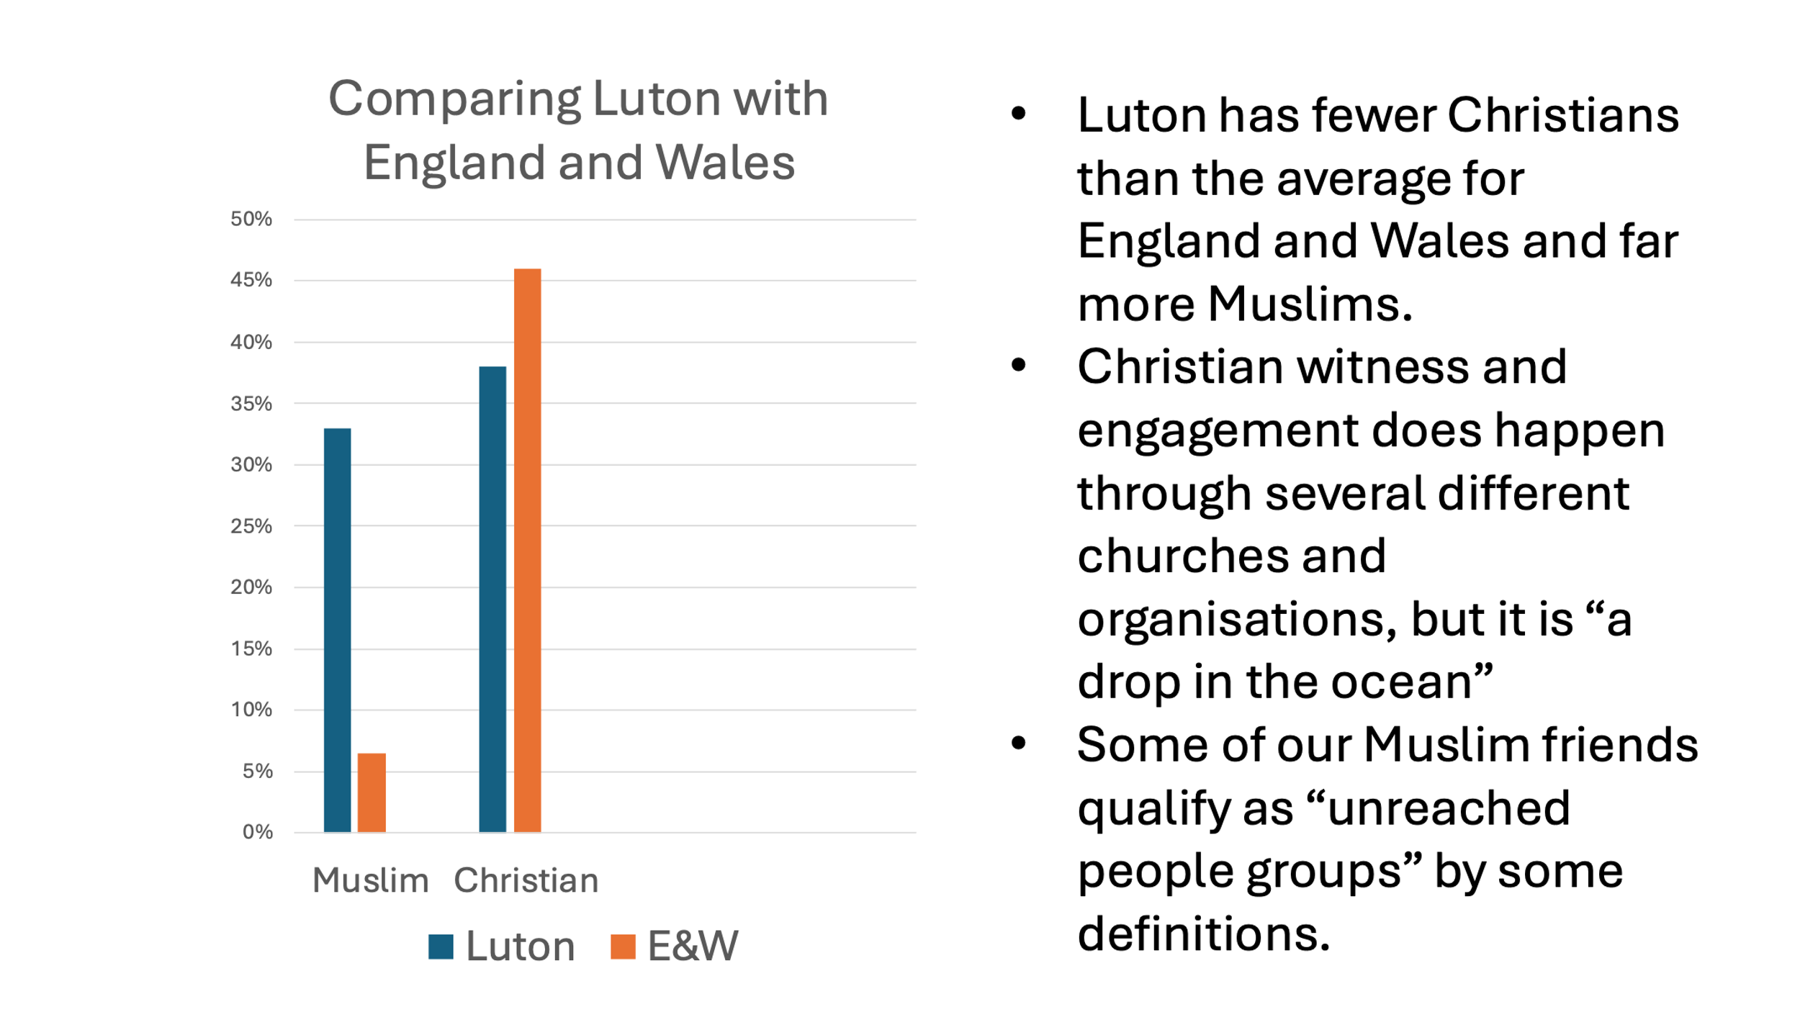

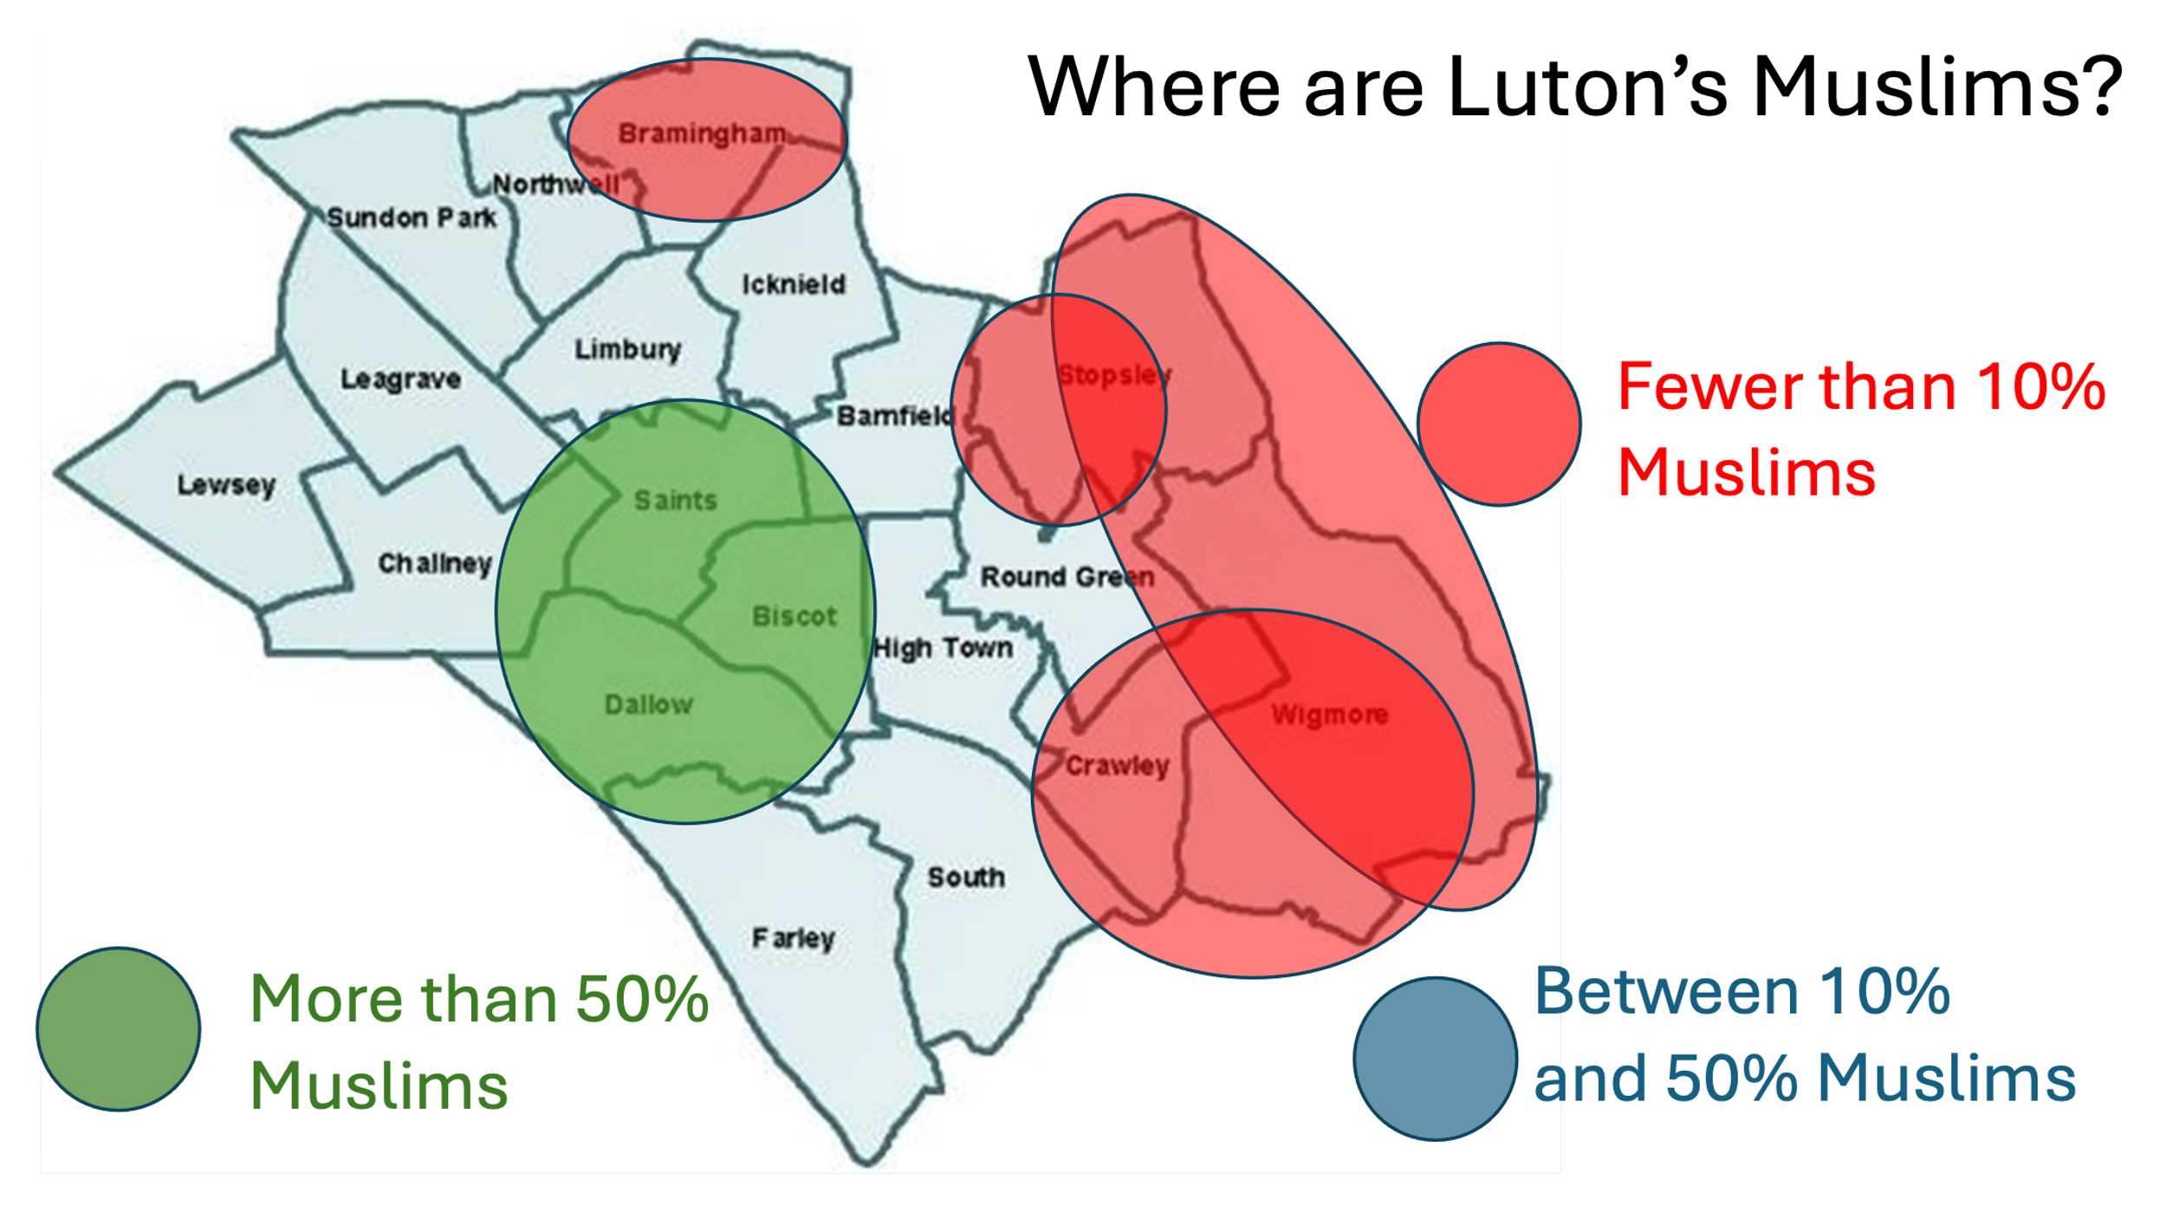Interestingly, the greater than 50% Muslim area approximately coincides with areas defined by HMG as among the most deprived in the country. Also, some of the fewer than 10% Muslim areas approximately coincide with some of the least deprived areas. Luton is divided.

1. It is hard to get data solely for Dunstable so most of the statistics used are for Central Bedfordshire.